# BURGERS & PANINIS

Served with fries or house salad.

Substitute Caesar salad for $1.00

DINO CLUB PANINI • $13.50

•chicken, ham, bacon & cheddar

CHIPOTLE CHEESESTEAK PANINI • $15.50

•roast beef, onions, peppers, cream cheese, chipotle mayo

BEEF DIP • $15.00

•roast beef served on a toasted baguette served with au jus

BBQ BACON CHEESEBURGER • $14.50

•6 oz. patty smothered in tangy BBQ sauce & topped with crisp bacon & cheddar

MUSHROOM SWISS BURGER • $14.50

•6 oz. patty topped with sautéed mushrooms & Swiss cheese

T-REX BURGER • $15.50

•breaded chicken breast soaked in hot sauce topped with jalapenos, bacon & Swiss

CHICKEN CORDON BLEU BURGER • $13.50

•grilled chicken breast, ham, Swiss cheese & garlic aioli

COLD ITALIAN DELI SANDWICH • $13.25

•assorted Italian deli meats, lettuce, tomato, onion & pesto mayo served on a Vienna bun

# APPETIZERS

HERBIVORE SPINACH DIP • $9.50

•a mix of cream cheese & spinach baked & topped with mozzarella. Served with tortilla chips

CLASSIC POUTINE • $7.50 (SM) • $11.50 (LG)

•cheese curds topped with our home made gravy

DRY GARLIC RIBS • $10.50

•boneless pork ribs served with lemon wedge

PTERODACTYL WINGS • $11.50

•hot, BBQ, teriyaki, honey garlic, salt & pepper, lemon pepper, chef’s creation

CHICKEN & WAFFLES • $10.50

• Two chicken fingers placed on top of a Belgian waffle & drizzled with maple cream

FRIES • $4.00 (SM) • $6.00 (LG)

YORKIE BITES • $10.50

•roast beef stuffed Yorkshire pudding, served with horseradish au jus

# 

# SOUPS & SALADS

SCALLOP BACON CHOWDER • $8.00

SOUP OF THE DAY • $6.50

CAESAR SALAD • $7.50 (SM) • $10.50 (LG)

HOUSE SALAD • $6.50 (SM) • $9.50 (LG)

•balsamic, raspberry vinaigrette, thousand island, ranch

Add chicken to salads • $4.00

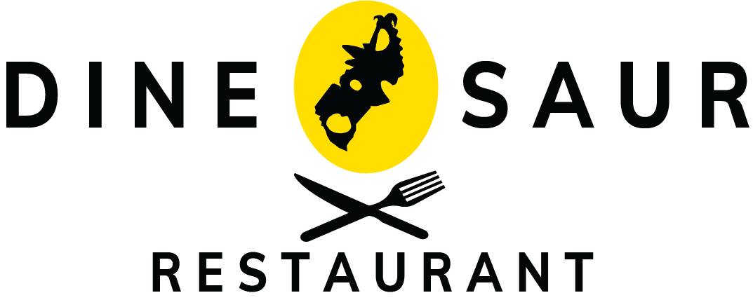



# DESSERT

NEW YORK CHEESECAKE • $8.00

•topped with caramel or strawberry sauce

WARM CHOCOLATE LAVA CAKE • $9.00

DEEP DISH APPLE PIE • $7.50

CARROT CAKE • $8.00

•Served warm with cream cheese

# BEVERAGES

CAN OF POP - $2.50

-pepsi, 7-UP, root beer, iced tea, diet pepsi, ginger ale

BOTTLED WATER - $2.50

JUICE - $3.00

-orange or apple

JUICE BOX - $1.75

COFFEE OR TEA - $2.50

HOT CHOCOLATE - $2.50

TERRIFIC TOFFEE - $2.50

FRENCH VANILLA - $2.50

.

# ALCOHOLIC BEVERAGES

DOMESTIC BEER • $6.00

•Pilsner, Budweiser, Coors Light, Kokanee, Canadian

LOCAL BEER • $6.00

•Honey Brown, Due North

IMPORT BEER • $7.00

•Heineken, Corona

WINE • $8.00 (6oz) • $11.00 (9oz)

•Pinot Grigio, Sauvignon Blanc, Moscato

•Cabernet Sauvignon, Malbec

PREMIUM HIGHBALLS • $5.75

COFFEE & BAILEYS • $6.50

DINO BUZZ • $5.25 (1oz) • $6.50 (2oz)

•Vodka, Blue Curacao, 7-up, Orange Juice

ATOMIC LEMONADE • $5.25 (1oz) • $10.25 (2oz)

•Vodka, 7-up, Lemonade, Grenadine

TEQUILA SUNRISE • $5.25 (1oz)

•Tequila, Orange Juice, Grenadine

CAESAR • $5.75 (1oz) • $7.25 (2oz)

•Vodka, Clamato Juice, Hot Sauce, Worcestershire Sauce

PARALYZER • $6.00 (1oz)

•Vodka, Kahlua, Milk, Cola

GIN & TONIC • $5.75 (1oz)

•Gin & Tonic Water

STRAWBERRY BLISS • $5.50 (1oz)

•White Rum, Moscato, Apple Juice, 7-up, Strawberry Garnish



# PIZZA

FOGHORN LEGHORN • $26.00 (12”) • $29.50 (14”)

• BBQ chicken with peppers, onions, jalapenos & tomatoes

PEPPERONI & CHEESE • $24.50 (12”) •$27.50 (14”)

THE CARNIVORE • $26.00 (12”) • $29.50 (14”)

• Chorizo, pepperoni, ham & bacon

HAWAIIAN • $24.50 (12”) • $27.50 (14”)

• Ham & pineapple

GARDEN • $22.50 (12”) • $26.00 (14”)

• Spinach, peppers, onions, tomatoes, black olives & mushrooms

MARGHERITA • $22.00 (12”) • $25.50 (14”)

• Mozzarella, parmesan & basil

CANADIAN PIZZA • $25.50 (12”) • $29.00 (14”)

•pepperoni, mushroom, bacon & cheese

RUSTICO ITALIANO • $26.25 (12”) • $29.50 (14”)

•prosciutto, genoa, sopprasatta, red onion, basil, parmesan & mozzarella

# ENTREES

CHICKEN FINGERS & FRIES • $15.00

STEAK SANDWICH • $22.00

•8 oz. striploin grilled to your preference. Served with sautéed mushrooms & onions on a French baguette

CALABRESE PENNE • $16.00

•chorizo, peppers, onions tossed in tomato sauce & sprinkled with parmesan

CHICKEN PESTO PENNE • $16.00

•grilled chicken breast cooked in our homemade pesto Alfredo sauce

TERIYAKI CHICKEN • $18.00

•grilled teriyaki chicken served with rice & vegetables

# PIZZA

***SENIORS & MEMBERS RECEIVE 10% OFF THE ENTIRE MENU***