WEEKLY SPECIALS

Tuesday

Seniors Day, 10% off food and free Coffee

$10 Breakfast Skillet

Wednesday

Wing Wednesday at $5.75 a pound

Or

2 beers and a pound of wings for $16.50

Thursday

This or that Thursday!

Chefs special from 4 to 7pm

House wine 6oz for $6 or 9oz for $9

Friday

Party Platter Friday

2 person platter for $15.95 or 4 person for $23.95

$4.75 Dino Buzz beverage

Saturday

Sangria Saturday ($22 for a pitcher of red or white wine)

$8 for a glass of Sangria

$6 Dessert off the menu

Sunday

Sunday Brunch $20.95 per person

Kids brunch (6-12) $12.95

Kids (0-5) eat free

Caesars $5.25 single $6.75 Double

$4.50 Mimosa

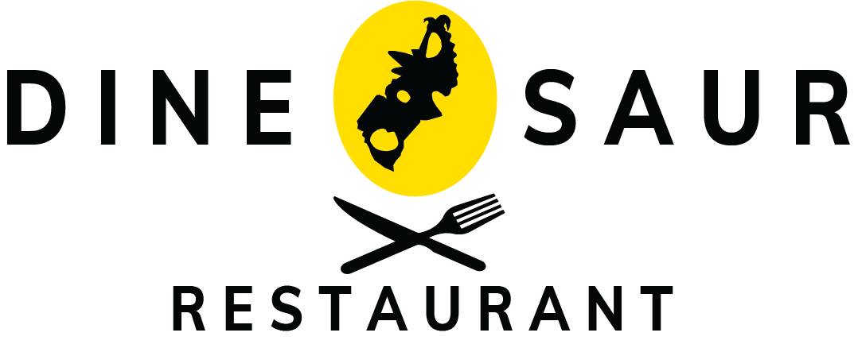

# BREAKFASTBREAKFAST

SERVED ALL DAY!

BACON & EGGS - $10.95

-Two eggs cooked any style served with hash browns & toast

DENVER CHEESE OMELETTE - $11.95

-Two whipped eggs filled with ham, peppers, onion & cheddar, served with hash browns & toast

MEAT LOVERS SKILLET - $12.95

-Bacon, sausage, ham folded in 2 scrambled eggs, placed on hash browns and baked with cheddar, served with choice of toast

PANCAKES • $7.95

-Three pancakes served with fresh strawberries & whipped topping

KIDS PANCAKES • $4.95

-Four mini pancakes served with strawberry & whipped topping

YOGURT PARFAIT • $5.50

-layers of yogurt & granola topped with whipped cream

BELT SANDWICH - $10.50

-Fried egg, bacon, lettuce, tomato, mayonnaise on your choice of bread, served with hash browns.

Add cheese -$0.75

TOAST • $2.95

-served with peanut butter & strawberry or raspberry jam