WEEKLY SPECIALS

Tuesday

Seniors Day, 10% off food and free coffee

$10 Breakfast Skillet

Wednesday

Wing Wednesday at $6.50 a pound

Or

2 domestic beers and a pound of wings for $17.00

Thursday

This or That Thursday!

Chefs special from 4 to close

House wine 6oz for $6.00 or 9oz for $9.00

Friday

Party Platter Friday

4 person for $23.95

$4.75 Dino Buzz beverage

Saturday

Sangria Saturday

($22 for a pitcher of red or white wine)

$6 Dessert off the menu

Sunday

Sunday Brunch $20.95 per person

Month end Brunch $26.95

Kids brunch (6-12) $12.95

Month end Brunch $15.95

Kids (0-5) eat free

$4.75 Mimosa

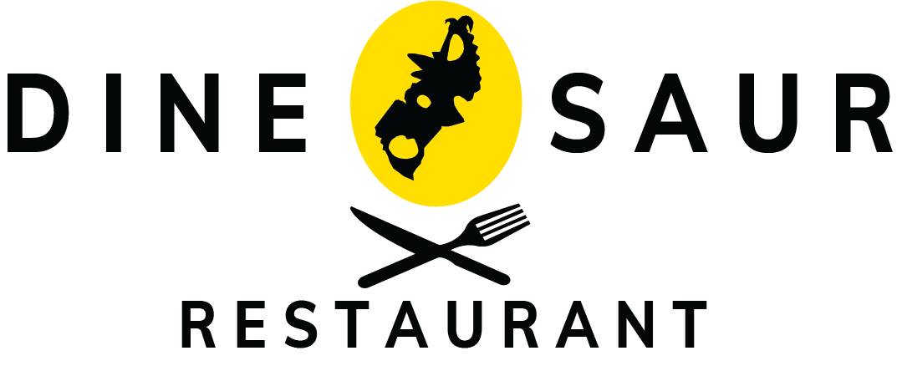

# BREAKFASTEAKFAST

SERVED ALL DAY!

TWO EGG BREAKFAST • $10.95

• Two eggs cooked any style served with hash browns & toast, choice of bacon or sausage.

DENVER CHEESE OMELETTE • $11.95

• Two whipped eggs filled with ham, peppers, onion & cheddar, served with hash browns & toast.

VEGGIE OMELETTE • $10.95

•Two whipped eggs filled with tomato, onion, mushroom, peppers & cheese, served with hash browns and toast.

THE SCICILIAN • $12.95

• Chorizo, onion, pepperoncini, folded in 2 scrambled eggs, placed on hash browns & baked with pepper Jack cheese, served with toast.

MEAT LOVERS SKILLET • $12.95

• Bacon, sausage, ham folded in 2 scrambled eggs, placed on hash browns and baked with cheddar, served with choice of toast

PANCAKES • $7.95

• Three pancakes served with strawberry topping & whipped topping.

FRENCH TOAST • $7.95

• Three pieces served with strawberry topping & whipped topping & powdered sugar.

YOGURT PARFAIT • $5.50

• Layers of yogurt & granola topped with berries & whipped cream.

BELT SANDWICH - $10.50

• Fried egg, bacon, lettuce, tomato, mayonnaise on your choice of bread, served with hash browns.

Add cheese -$0.75

FRUIT SALAD • $6.00

TOAST • $2.95

• served with peanut butter & strawberry or raspberry jam.