# BURGERS, SANDWICHES & PANINIS

Served with fries or house salad or soup of the day.

Substitute Caesar salad for $1.00

DINO CLUB PANINI • $13.50

•Chicken, ham, bacon, lettuce, tomato & cheddar served on a Vienna bun.

CHICKEN SWISS PANINI • $14.00

•Chicken breast, onions, lettuce, tomato, Swiss cheese, pesto mayo, served on a Ciabatta bun.

BEEF DIP • $15.00

•Roast beef served on a toasted baguette served with au jus.

PULLED PORK SANDWICH • $14.50

• BBQ pulled pork served on a Brioche bun and topped with coleslaw.

BENEDICT BURGER • $15.50

• 6oz. patty topped with egg, ham, and hollandaise sauce.

THE DINE-O-SAUR BURGER • $18.50

• 6oz. BBQ beef patty, 4 oz. chicken breast, bacon, Swiss & cheddar.

BBQ BACON CHEESEBURGER • $14.50

• 6 oz. patty smothered in tangy BBQ sauce & topped with crisp bacon & cheddar.

MUSHROOM SWISS BURGER • $14.50

• 6 oz. patty topped with sautéed mushrooms & Swiss cheese.

T-REX BURGER • $15.50

• Breaded chicken breast soaked in hot sauce topped with jalapenos, bacon & jalapeno Jack cheese.

CHICKEN CORDON BLEU BURGER • $13.50

• Grilled chicken breast, ham, Swiss cheese & garlic aioli.

COLD ITALIAN DELI SANDWICH • $13.50

• Assorted Italian deli meats, lettuce, tomato, onion, Swiss cheese & pesto mayo served on a Vienna bun.

# APPETIZERS

SNAKE BITES • $9.50

• Breaded chicken pieces tossed in sweet chili sauce topped with green onion and fried tortillas

BRUSCHETTA • $8.50

• 5 rusks topped with homemade bruschetta and parmesan cheese.

PTERODACTYL WINGS • $11.75

• Hot, BBQ, teriyaki, honey garlic, salt & pepper, lemon pepper, chef’s creation.

COCONUT CURRY PRAWNS • $12.50

• Prawns cooked in coconut curry sauce served with naan bread and sorbet.

CALAMARI • $11.50

• Half a pound of hand dusted calamari served with tzatziki.

YORKIE BITES • $10.50

• Roast beef stuffed Yorkshire pudding, served with horseradish aioli & au jus.

CLASSIC POUTINE • $7.50 (SM) • $11.50 (LG)

• Cheese curds topped with our house gravy

BBQ PULLED PORK POUTINE • $9.50

•French fries topped with BBQ pulled pork, cheese curds and house gravy.

FRIES • $4.00 (SM) • $6.00 (LG)

ONION RINGS • $6.00

BACON CHIVE DIP • $9.50

Mix of cream cheese, bacon and chives, baked and served with homemade tortilla chips.

BEDROCK BREAD • $9.00

Baked 8” pizza bread served with your choice of olive oil and balsamic or marinara sauce.

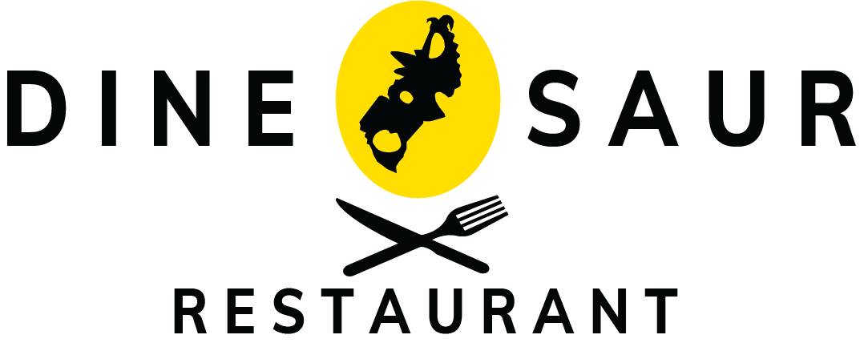



# ALCOHOLIC BEVERAGES

DOMESTIC BEER • $6.00

•Pilsner, Budweiser, Coors Light, Kokanee, Molson Canadian

IMPORT BEER • $7.25

•Heineken, Holland • Corona, Mexico • Stella Artois, Belgium

FROM THE CELLAR • $8.00 (6oz) • $11.00 (9oz)

**White**

• Moscato, Italy • Pinot Grigio, South Africa • Chardonnay, USA

**Red**

• Cabernet Sauvignon, Canada • Merlot, Australia •San Giovese, Italy

PREMIUM HIGHBALLS (1oz) • $5.75

NORTHERN LIGHTS (1oz) • $5.75

• White Rum, Blue Curacao, Lemonade, Grenadine

DINO BUZZ • $5.25 (1oz)

• Vodka, Blue Curacao, 7-up, Orange Juice

ATOMIC LEMONADE • $5.25 (1oz) • $9.75 (2oz)

• Vodka, 7-up, Lemonade, Grenadine

TEQUILA SUNRISE • $5.25 (1oz)

• Tequila, Orange Juice, Grenadine

CAESAR • $5.75 (1oz) • $10.25 (2oz)

• Vodka, Clamato Juice, Hot Sauce, Worcestershire Sauce

PARALYZER • $6.00 (1oz)

• Vodka, Kahlua, Milk, Cola

GIN & TONIC • $5.75 (1oz)

• Gin & Tonic Water

STRAWBERRY BLISS • $5.50 (1oz)

• White Rum, Moscato, Apple Juice, 7-up, Strawberry Garnish

COFFEE & BAILEYS (1oz) • $6.50

# DESSERT

NEW YORK CHEESECAKE • $7.50

• Topped with caramel or strawberry sauce

DEATH BY CHOCOLATE • $7.50

• 5 layer chocolate cake served with chocolate coulis

DEEP FRIED ICE CREAM • $6.50

• 2 balls of fried ice cream, served with fruit coulis and fresh fruit

STRAWBERRY RHUBARB CRISP • $6.50

•A delightful strawberry-rhubarb filling between a crunchy coconut cinnamon streusel

BEVERAGES

From the Tap • $2.95

• Pepsi, 7-UP, Root beer, Iced tea, Diet Pepsi, Ginger ale

Kids Pop • $2.00

JUICE - $3.00

• Orange or Apple

JUICE BOX - $1.75

• Orange or Apple

MILK • $3.00

CHOCOLATE MILK • $3.50

COFFEE OR TEA •$2.50

HOT CHOCOLATE •$3.00

TERRIFIC TOFFEE • $3.50

FRENCH VANILLA • $3.50

.

## dosnewAsset 1@4x

# PIZZA

MARGHERITA • $22.00 (12”) • $25.50 (14”)

• Mozzarella, parmesan & basil.

GARDEN • $22.50 (12”) • $26.00 (14”)

• Spinach, peppers, onions, tomatoes, black olives & mushrooms.

HAWAIIAN • $24.50 (12”) • $27.50 (14”)

• Ham & pineapple.

PEPPERONI & CHEESE • $24.50 (12”) • $27.50 (14”)

CANADIAN PIZZA • $25.50 (12”) • $29.00 (14”)

• Pepperoni, mushroom, bacon & cheese.

• BBQ PULLED PORK • $25.50 (12”) • $29.00 (14”)

• BBQ pulled pork, onion, mozzarella cheese.

THE CARNIVORE • $26.00 (12”) • $29.50 (14”)

• Chorizo, pepperoni, ham & bacon.

FOGHORN LEGHORN • $26.00 (12”) • $29.50 (14”)

• BBQ chicken peppers, onions, jalapenos & tomatoes.

RUSTICO ITALIANO • $26.25 (12”) • $29.50 (14”)

• Prosciutto, genoa, sopprasatta, red onion, basil, parmesan & mozzarella.

• SENIORS & MEMBERS RECEIVE 10% OFF THE ENTIRE MENU, EXCLUDES ALCOHOL

# SOUPS & SALADS

WATERMELON MINT GAZPACHO • $7.50

SOUP OF THE DAY • $6.50

CAESAR SALAD • $7.50 (SM) • $10.50 (LG)

SPINACH SALAD • $7.50 (SM) • $11.00 (LG)

• Strawberry, Feta, candied walnuts, onion, mandarins, served with raspberry or Balsamic vinaigrette.

HOUSE SALAD • $6.50 (SM) • $9.50 (LG)

• Balsamic, raspberry vinaigrette, thousand island, ranch. Add Chicken • $3.00

# Add chicken to salads •

# ENTREES

STIRFRY• $12.50

• Vegetable stir fry served with basmati rice & ginger teriyaki sauce.

• Add Chicken • $3.00 • Add Beef • $3.00

MAC AND CHEESE • $15.00

• Jalapeno, bacon, baked in our home made cheese sauce and topped with bread crumbs

CALABRESE PENNE • $16.00

• Chorizo, peppers, onions tossed in tomato sauce & sprinkled with parmesan.

BUTTER CHICKEN • $16.00

• Grilled chicken breast cooked in our curry butter sauce, served with basmati rice and naan bread.

CHICKEN FINGERS & FRIES • $15.00

STEAK SANDWICH • $22.00

• 8 oz. striploin grilled to your preference. Served with sautéed mushrooms & onions on a French baguette.

10oz. STRIPLOIN • $26.00

• 10 oz. striploin grilled to your preference. Served with baked potato and steamed vegetables.

***SENIORS & MEMBERS RECEIVE 10% O***