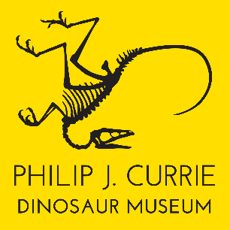
Media Release

Who’s The Next Philip J. Currie?

August 11, 2021
Photo caption: Program leader Matt Rhodes is shown at a local fossil excavation preparing for incoming dinosaur enthusiasts.
WEMBLEY, AB – The next great palaeontological discovery could be under the next stone! Over the coming week, the Palaeontologist for a Day Program will help dinosaur enthusiasts in the region dig right into their passion.

Full- and half-day programs are available from August 14-22. Participants will join an actual palaeontological excavation, working shoulder-to-shoulder with researchers and field crews exploring the Pipestone Creek bonebed for traces of dinosaurs and answers to what was really happening in our area millions of years ago.

Booking information and program details can be found at www.dinomuseum.ca. Enrolment can be considered as a gift idea for a friend or family member. Enquiries can be made at visitorservices@dinomuseum.ca or by calling 587-771-0662.

“We’re excited to have Matt Rhodes leading the program,” says Executive Director Linden Roberts. “Matt is a recent graduate and studied under Dr. Philip Currie. We also have Jackson Sweder back as his assistant.”

As a part of the excavation team, participants begin their day with a behind-the-scenes tour of the museum. They’re then transported to the bonebed with the other dinosaur hunters, equipped with a museum tote bag, water bottle, and authentic fossil-hunting tools to set about scouring the bonebed for the next big discovery with the assistance of our palaeontology team.

There will also be time to take a break, breathe in the serene landscape, and have lunch (snack for the half-day program) hand-packed by the museum’s catering staff.

As one of the densest fossil sites in the world, Pipestone Creek is a treasure trove of prehistoric information, but there is still much unknown. This is an active fossil site and each new fossil uncovered provides another piece of the puzzle, and enhances the understanding of the enigmatic animals that once made their homes in the region.

The Philip J. Currie Dinosaur Museum – a 41,000 square foot world-class facility named for Canada’s preeminent palaeontologist and highlighting the rich fossil resources of Northern Alberta – opened its doors to the public on September 26, 2015. It is Canada’s second devoted dinosaur museum, and is located 19 kilometres west of the City of Grande Prairie in the Town of Wembley.
-30-

Media enquiries may be directed to:
Linden Roberts
Executive Director
Philip J. Currie Dinosaur Museum
780-913-7558
lroberts@dinomuseum.ca

